EXP 12 K MANOJ KIRAAN

240701305

Create Approval Process Using Zoho Creator

Aim
To implement an approval process in Zoho Creator for reviewing and approving investigation reports in the EviTrace application.

Procedure
- Open the EviTrace application in Zoho Creator.
- Navigate to Workflow → Approvals.
- Create an approval workflow named
Investigation_Report_Approval for the Investigation Reports form.
- Configure the workflow to trigger when an investigation report is submitted for review.
- Assign the Auditor role as the approver.
- Configure the approval actions to update the report status to Approved when accepted and Returned for Correction when rejected.
- Enable the approval workflow.
- Submit a test investigation report and verify that the approval request appears for the Auditor.
- Test the approval and rejection process and verify the updated status.

Output

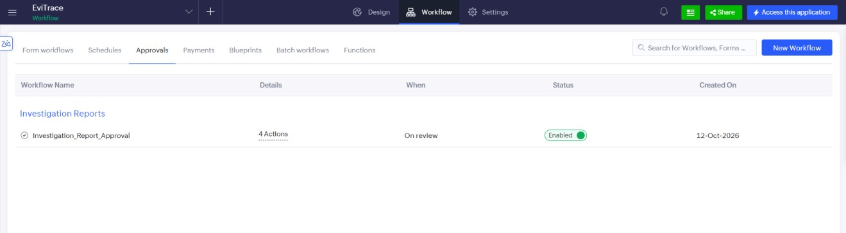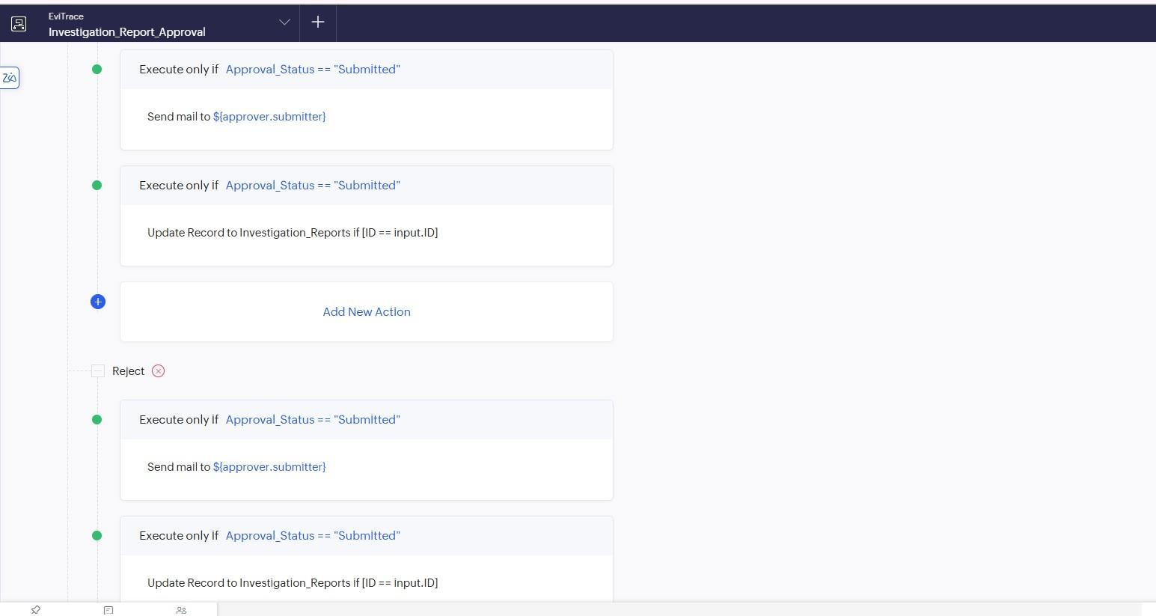

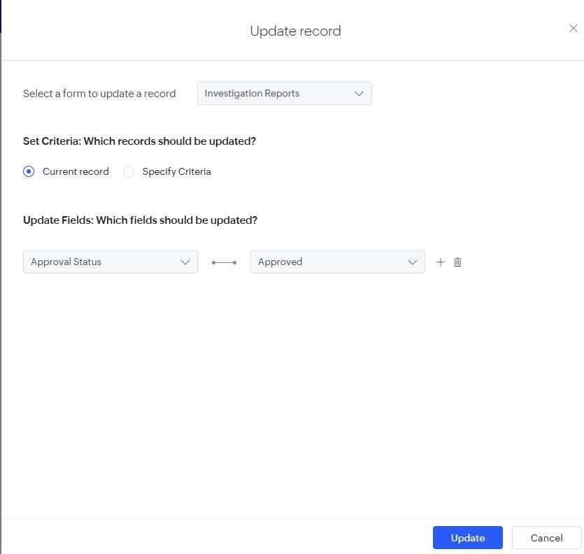

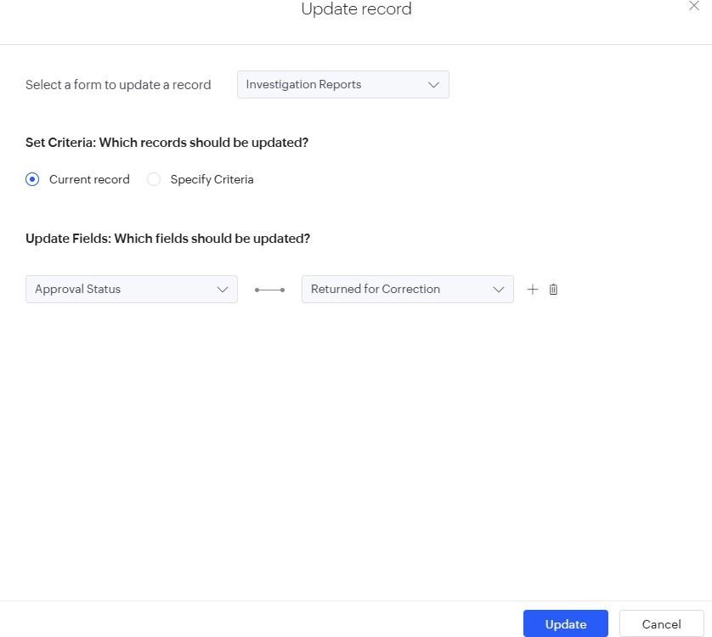

Result
The Investigation_Report_Approval workflow was implemented to enable the Auditor to review investigation reports and approve or return them for correction.

